Oxygen Editor Quickstart:
How do I create, assemble, and build my first DITA publication in Syncro Soft Oxygen Editor?
Stanley Doherty, Ph.D.

Guidepost

Purpose: This resource provides step-by-step procedures for how to author and publish XML DITA content in the Syncro Soft Oxygen Editor.

Learning objective(s):
- Create DITA topics and maps.
- Organize publications by linking topics to a map.
- Add XML content to generic, concept, task, and reference topics.
- Generate PDF output from a map.

Use case (scenario)
Let’s pretend that you are a member of a research team exploring generative AI applications. Your colleagues have researched ChatGPT and WOMBO Dream, but need someone (you) to provide an introduction to Google Gemini.

You don’t know whether your research team would be delivering PDF, web pages, or both. To play it safe, you want to separate your content from its presentation.

Your introduction should include a working definition of generative AI (concept), a procedure about using Google Gemini (task), and a set of sample questions to test Google Gemini (reference).

Each one of those entries will be a separate DITA topic referenced from a DITA map. You can then process that one DITA map to produce multiple output formats.

Task overview
- Download and install Oxygen Editor.
- Apply your Oxygen license (academic discount or 30-day free trial).
- In Oxygen, create and name a DITA map.
- Create and name your DITA topics.
- Populate the DITA topic(s) with content.
- Create references in your map to your topic(s).
- Save everything.
- Choose a transformation type in Oxygen and build your content.

Create a DITA map
- In Oxygen, choose File - New to open the New dialog.
- Double-click the Map [DITA / Maps] template under Framework Templates / DITA / Maps.
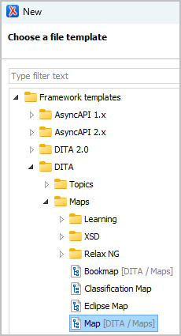
- In the DITA Maps Manager, right-click the map icon () and choose Edit Properties.
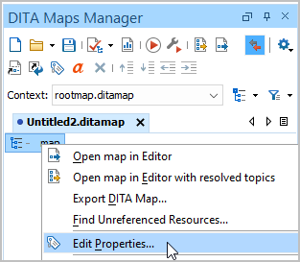
- In the Edit Properties dialog, enter a value for the @title attribute and click OK.
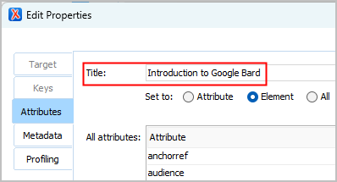
- Choose File - Save to save the map with a relevant name to a local folder.
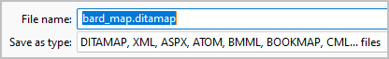

What have we accomplished?
- DITA is modular. Unlike Google Docs or MS Word, you author content in small modules (topics) which you then assemble into various publications using maps.

- Maps are the blank canvas upon which you organize your publication. They provide the higher brain functions.

Create a DITA topic (generic topic)
- In Oxygen, choose File - New to open the New dialog.
- Double-click the Topic [DITA / Topics] template under Framework Templates / DITA / Topics.
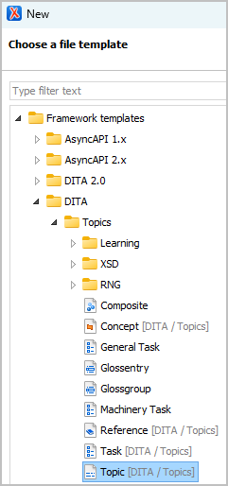
Oxygen creates the topic and displays it in the right-hand Editor pane.
- In the Editor pane, click the Author button to display DITA content with tags.
- Choose DITA - Tags display mode - Block tags to display element tags.
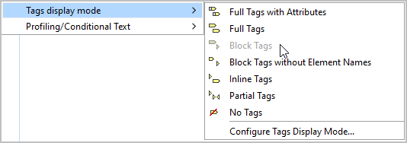
- Provide values for the topic <title>, <shortdesc>, and the introductory <p> (paragraph) elements.
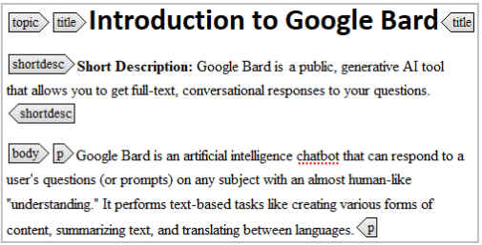
- Save the DITA topic with a relevant name to the same local folder.
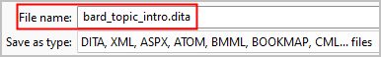

Create a DITA topic (concept)
- In Oxygen, choose File - New to open the New dialog.
- Double-click the Concept [DITA / Topics] template under Framework Templates / DITA / Topics.
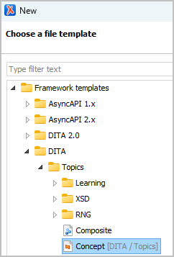
- Provide content for the topic <title>, <shortdesc>, and opening <p> elements.
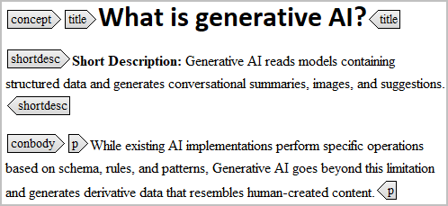
- Save the DITA topic with a relevant name to the same local folder.
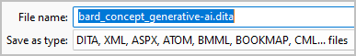

Create a DITA topic (reference)
- In Oxygen, choose File - New to open the New dialog.
- Double-click the Reference [DITA / Topics] template under Framework Templates / DITA / Topics.
- Place your cursor inside the <refbody> element tag.
- Right-click and choose Insert - Insert Section.
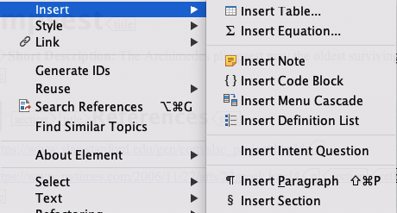
- Right-click within the <section> element and insert a <p> and <ul> list (including <li>s).
- Provide content for the topic <title>, <shortdesc>, and <section> elements.
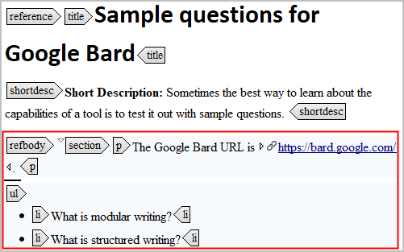
- Save the topic to your local folder with an appropriate name.
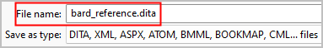

Create a DITA topic (task)
- In Oxygen, choose File - New to open the New dialog.
- Double-click the Task [DITA / Topics] template under Framework Templates / DITA / Topics.
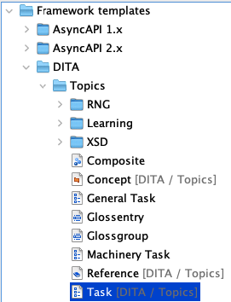
- Provide content for the <title> and <shortdesc> elements.
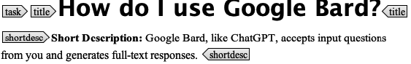
- Provide content for the <context> and <step> elements inside <taskbody>.
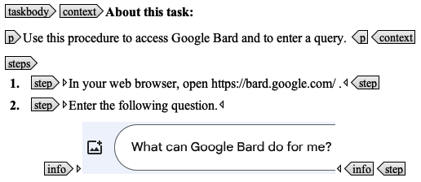
- Save the topic to your local folder with an appropriate name such as bard_task.dita.

What have we learned?
- DITA topics are the building blocks of DITA publications.
- All DITA topics have some common elements such as <tiltle> and <shortdesc>.
- Most DITA topics are "typed". The elements contained in a task or reference topic are different from the elements in a generic or concept topic. Topic typing encourages writers to focus on the specific type of information that they are developing.

Reference your DITA topics from your map
- Open the DITA map that you created earlier in this tutorial.
- In the DITA Maps Manager, right-click the map () icon and choose Append child - Reference.
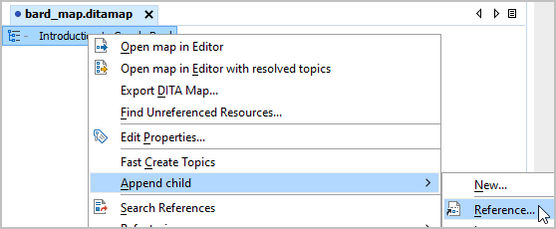
- In the Insert Topic Reference dialog, navigate to the folder containing your map and topics.
- Select the topics (*.dita) you created and click the Insert and close button.
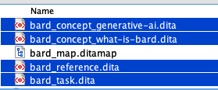
The topics now appear in your DITA map.
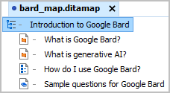
- In the DITA Maps Manager, use the ALT(Win)/Option(Mac)+arrow keys to move and indent the topic references in your map.
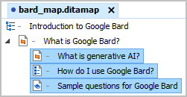
When you generate output, this topic hierarchy defines the outline for your deliverable.
- Choose File - Save as to save your map.

What have we learned?
- In modular environments such as DITA, the modules you author (topics) and the assemblies within which you organize your modules (maps) are distinct.

- Topics inherit their level and formatting from the map that references them. If you referenced the same topic in three different maps, it could appear as an H1, H2, or H3 in the three sets of generated output.

- Topics provide content. Maps provide hierarchy.

Build your DITA content
- Verify that you have your DITA map (bard_map.ditamap) selected in the DITA Maps Manager.
- Choose DITA Maps - Configure Transformation Scenario to display a list of processing options.
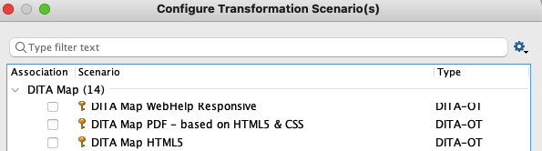
- Click the scenario type that you want to build and click Apply Associated.
Oxygen processes your DITA map, generating the desired output.
Here is a PDF table of contents generated from our sample files.
And the generated topic content.
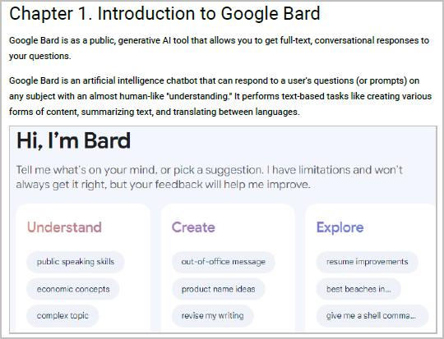

What have we learned?
- DITA separates source XML content from generated PDF or HTML presentation.

- DITA processors read one DITA map and generate a specific set of PDF, HTML5, or WebHelp deliverables. This is genuine single-source publishing.

- You can customize an out-of-the-box DITA processor in Oxygen to make it look like a particular presentation style.

Thank You!
See https://acm-sigdoc-structured.org to learn more about committee activities, available resources, and volunteer opportunities.

