Heretto Quickstart:
How do I create, assemble, and build my first DITA publication in Heretto CCMS?
Stanley Doherty, Ph.D.

Guidepost

Purpose: This resource provides step-by-step procedures for how to author and publish XML DITA content in the Heretto CCMS.

Learning objective(s):
- Create DITA topics and maps.
- Organize publications by linking topics to a map.
- Add XML content to generic, concept, task, and reference topics.
- Generate PDF output from a map.

Use case (scenario)
Let’s pretend that you are a member of a research team exploring generative AI applications. Your colleagues have researched ChatGPT and WOMBO Dream, but need someone (you) to provide an introduction to Google Gemini.

You don’t know whether your research team would be delivering PDF, web pages, or both. To play it safe, you want to separate your content from its presentation.

Your introduction should include a working definition of generative AI (concept), a procedure about using Google Gemini (task), and a set of sample questions to test Google Gemini (reference).

Each one of those entries will be a separate DITA topic referenced from a DITA map. You can then process that one DITA map to produce multiple output formats.

Task overview
- Log in to a Heretto CCMS cloud account.
- Create a folder in Heretto for your DITA files.
- Create a DITA map.
- Create some DITA topics (general, concept, task, reference).
- Populate the topics with content.
- Create references from your DITA map to those topic(s).
- Publish your content using built-in processors as PDF, HTML, and web help.

Create a folder in Heretto for your content
- In a web browser, log in to Heretto CCMS.
- In the Browse tab, click the Content heading to display current folders.
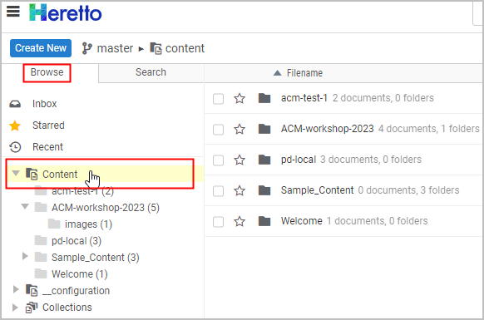
Note: The folders that you see in your repository will vary from this example.
- On the right-hand side of the toolbar, click the Create a new folder icon.
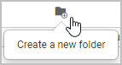
- In the Create Folder dialog box, provide a name for your new folder and click Create.
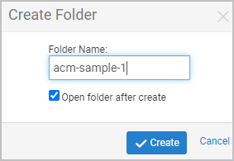
- Refresh (expand and collapse) the Content branch.
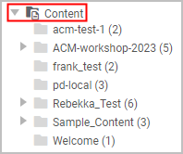
Heretto creates the folder and displays it in the Content branch.
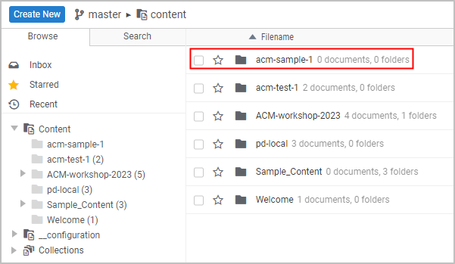

Create a DITA map
- Double-click the folder into which you want to add your map, for example acm-sample-1.
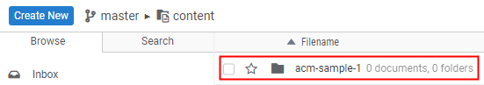
- Click the Create New button to display a list of available DITA map and topic types.
- Under the Map Types section, click the Map item to open the Create New: Map dialog box.
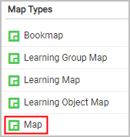
- In the Create New: Map dialog, provide a title for your map and a file name.
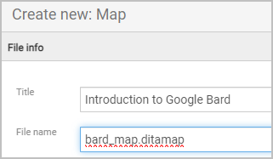
- Click Create & Edit to create the map.
Heretto displays the new map in the Map Editor.
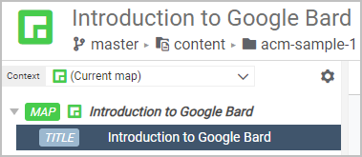
- Click the Open Library button at the bottom of the screen to display a list of available folders next to the Map Editor folders.
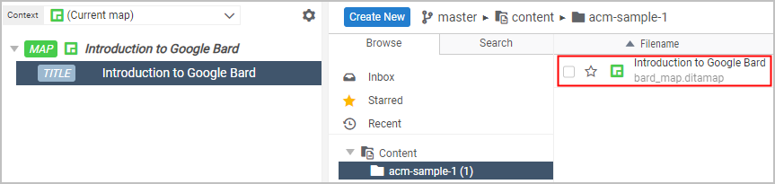
Heretto lists the new DITA map (bard_map.ditamap) in the folder named acm-sample-1.
We'll come back to this map after we have created some topics.
Heretto allows you to customize how much information it displays as you edit maps and topics. For example, in the DITA Map Editor, you can click the Settings icon to display a list of display options.
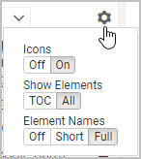

What have we accomplished?
DITA is modular. Unlike Google Docs or MS Word, you author content in small modules (topics) which you then assemble into various publications using maps.
Maps are the blank canvas upon which you organize your publication. They provide all the higher brain functions.

Create a DITA topic (generic topic)

- Select the folder into which you want to create the new topic.
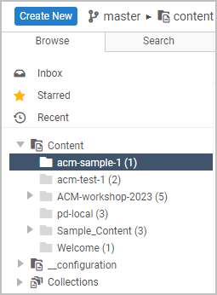
- Click the Create New button to display a list of available DITA map and topic types.
- In the list of Topic Types, click Topic.
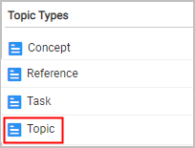
- In the Create New: Topic dialog box, provide a topic title and a file name.
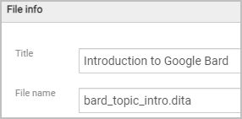
- Click the Create & Edit button to create the topic and to open it in the Topic Editor.
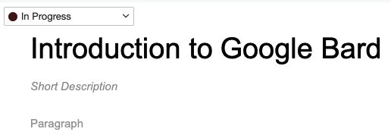
- Click the Options icon () and choose Full Tags to display DITA elements in the Topic Editor.
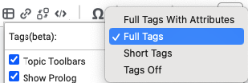
While you are learning DITA, it is useful to display the XML element names.
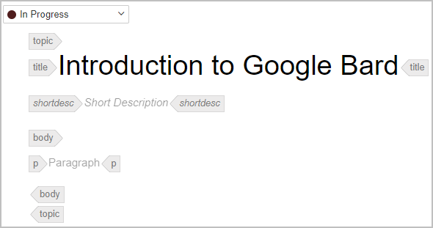
- Click the Open document in a new tab icon.
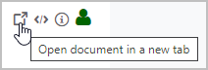
Displaying topics in separate tabs is not required, but convenient.
- Click inside the set of tags delimiting any element.
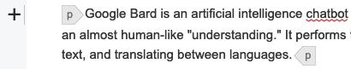
Heretto displays a plus sign (+) beside the selected element.
- Right-click to display a list of options.
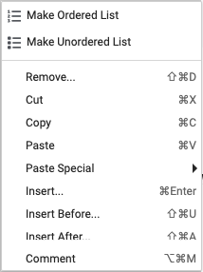
- Click Insert Before or Insert After to specify the location of the new element relative to the select element in the topic.
- From the list of available elements, click the one you want to insert, for example a <p> (paragraph).
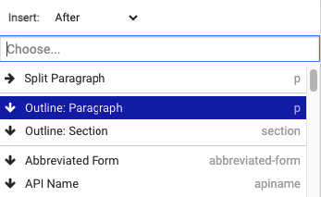
Heretto inserts the element and places the cursor where you can enter content.
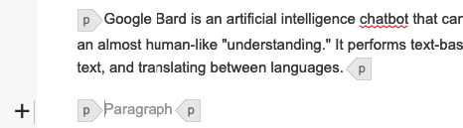

What have we accomplished?
The DITA generic topic is the most flexible topic type because it makes no assumption about what sort of content it contains. The generic topic is actually useful as a root (top-most) topic in your map or map branch. You can then nest more specific topic types such as "concept" or "task" beneath these root topics.
In linear writing, we might call generic topics "transition sections" or "orientation topics".

Create a DITA topic (concept topic)
- Select the folder into which you want to create the new topic.
- Click the Create New button to display a list of available DITA map and topic types.
- In the list of Topic Types and click Concept.
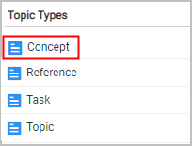
- In the Create New: Concept dialog box, provide a topic title and a file name.
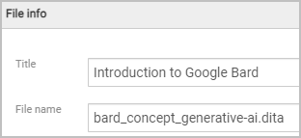
- Click the Create & Edit button to create the topic and to open it in the Topic Editor.
- Click the Open document in a new tab icon.
Displaying topics in separate tabs is not required, but convenient.
- Click inside the <shortdesc> element and enter text that summarizes the topic. .
- Click inside the <conbody> element and insert a paragraph <p> for content that begins topic content.
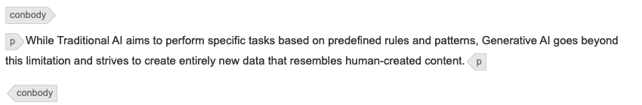
DITA concept topics answer the question, "What is this thing?" Our topic answers the question, "What is generative AI?" It is useful to place concept topics toward the top of your map to help orient the reader.

Create a DITA topic (task topic)
- Select the folder into which you want to create the new topic.
- Click the Create New button to display a list of available DITA map and topic types.
- In the list of Topic Types click Task.
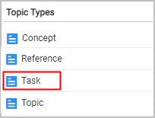
- In the Create New: Concept dialog box, provide a topic title and a file name.
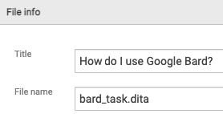
- Click the Create & Edit button to create the topic and to open it in the Topic Editor.
- Click the Open document in a new tab icon.
- Click inside the <shortdesc> element and enter text that summarizes the topic.
- Click inside the <taskbody> <context> element and describe the context for the task.
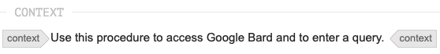
- In the <steps> element, specify the following <step> elements for the procedure.
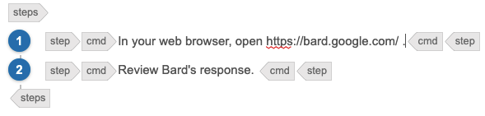
DITA task topics answer the question, "How do I use this thing?"

Create a DITA topic (reference topic)
- Select the folder into which you want to create the new topic.
- Click the Create New button to display a list of available DITA map and topic types.
- In the list of Topic Types click Reference.
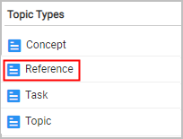
- In the Create New: Concept dialog box, provide a topic title and a file name.
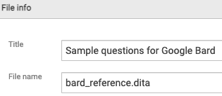
- Click the Create & Edit button to create the topic and to open it in the Topic Editor.
- Click the Open document in a new tab icon.
- Click inside the <shortdesc> element and enter text that summarizes the topic.
- Right-click inside the <refbody> element and insert a <section> element.
- Within the <section> element, create and populate an introductory paragraph <p>.
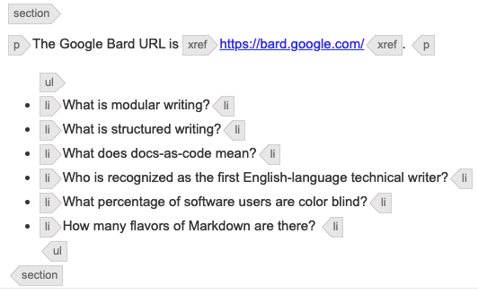
- Append an unordered list (<ul>) element and multiple list items (<li>).
DITA reference topics answer the question, "What other information is relevant to or part
of my subject?" Examples are common.

What have we learned?
- DITA topics are the building blocks of DITA publications.
- All DITA topics have some common elements such as <title> and <shortdesc>.
- Most DITA topics are "typed". The elements that are valid for one topic type may be different from the elements valid for another topic type. Topic typing
encourages writers to focus on the specific type of information that they are developing.

Reference your DITA topics from your map

- Double-click the DITA map that you created previously to open it in the Maps Editor.
- In the Maps Editor, right-click the <title> element to specify it as the location of a new element and its name.
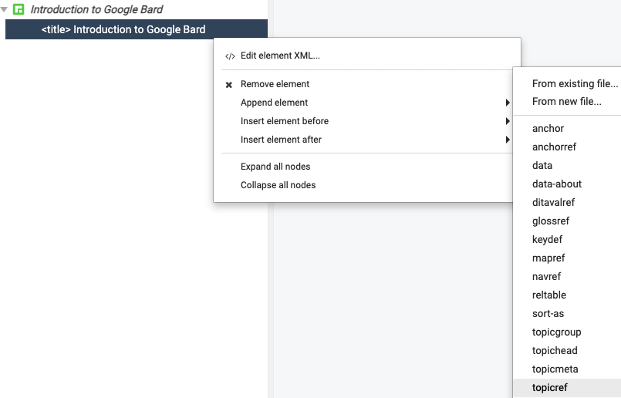
- Click topicref in the list of valid elements.
In this example, Heretto inserts a <topicref> element.
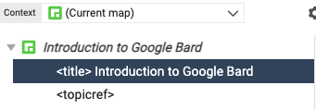
- Select the map <topicref> element and click the Edit element properties icon.
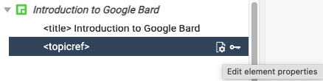
- In the Properties dialog box, click the Change button under the @href attribute to select the topic you want to reference from your map.
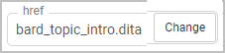
Heretto inserts a <topicref> element that references the topic file bard_topic_intro.dita with the topic title "Introduction to Google Bard."
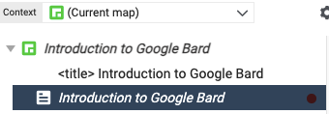
- Add references to the other topics that you have created.
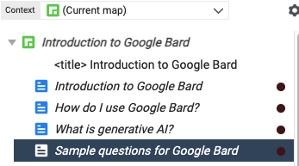
- Select a topic reference in the map and drag it to the appropriate position and indentation level.
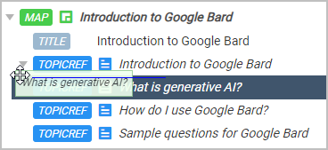
Heretto indents the <topicref> elements.
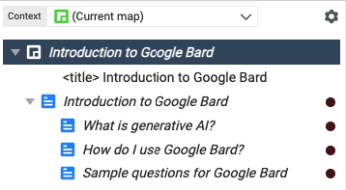
You now have all the maps and topics that you need to publish your DITA content.

What have we learned?
In modular environments such as DITA, the modules you author are topics and collections of those topics appear in maps. The same topic may appear in different maps, allowing you to publish content with different organizations.
Topics inherit their level and formatting from the map that references them. If you referenced the same topic in three different maps, it could appear as an H1, H2, or H3 in the three sets of generated output.
Topics provide content. Maps provide hierarchy.

Build your DITA content

- Under the Browse tab, select the folder that contains the map that you want to publish.
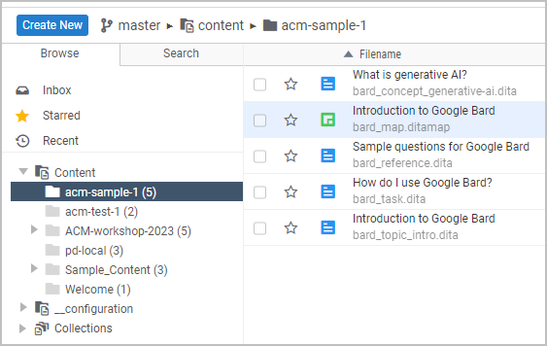
For an overview of publishing options in Heretto, see Heretto Publishing.
- Double-click the DITA map to open the map and the topics that it references in the editor.
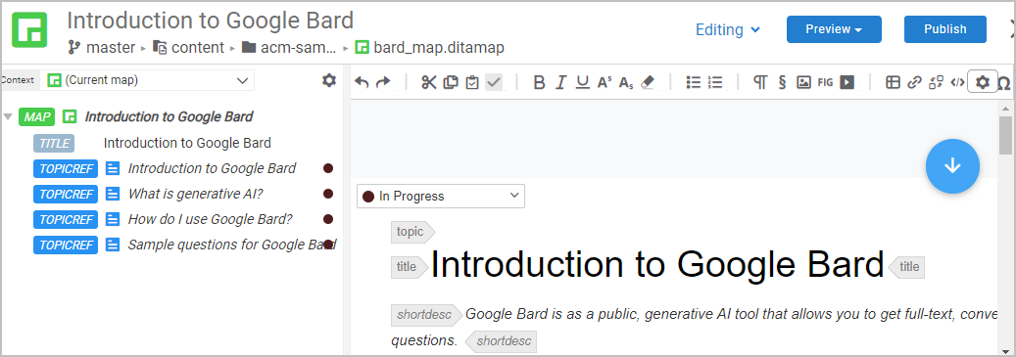
- Click the Publish button to specify that you want to publish the current map.
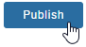
- In the Publish dialog box, click the publication scenario (output format) that you want.
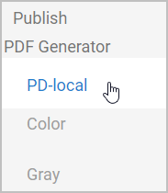
- Provide some metadata (a description) about this publication.
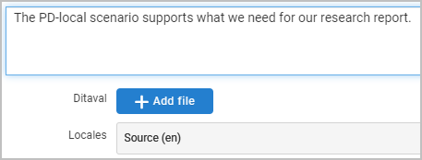
- Click the Publish button to submit your DITA sources to the PDF processor.
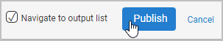
Heretto processes your content and provides a link to the generated
output (a PDF file in this case).
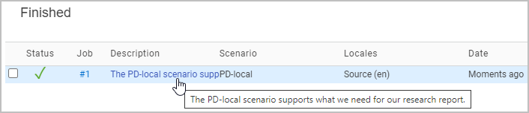
- Click the link in the Description column to open an inventory of your publications.
- Click the link under Key Assets to view the generated output.
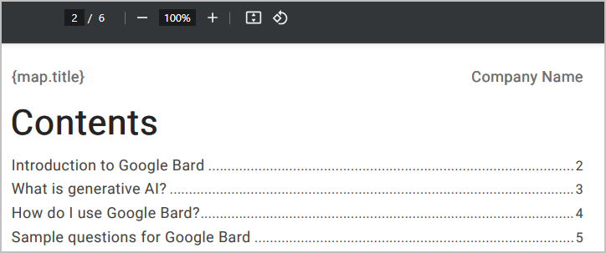
- Click the Download button to save the generated PDF to your Downloads folder.
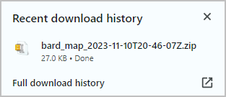

Conclusion
DITA separates source XML content from generated PDF or HTML presentation.
DITA processors read one DITA map and generate a specific set of PDF, HTML5, or WebHelp deliverables. This is genuine single sourcing.
If you have experience programming in XML, you can customize the out-of-the-box Heretto DITA processors to make your output reflect a particular presentation style.

Thank You!
See https://acm-sigdoc-structured.org to learn more about committee activities, available resources, and volunteer opportunities.

