Configuring Oxygen Editor
Stanley Doherty, Ph.D.

Guidepost
Syncro Soft Oxygen Editor is the leading XML editor in the world. It is usable, powerful, feature-rich, and scalable. In this context, "scalable" means that Oxygen offers features that support beginners, professionals, and experts. As your familiarity with XML, DITA, JSON, or Markdown increases, you'll find that Oxygen offers increasingly advanced features to support your learning and writing.

So - how do we configure Oxygen to make its beginner-oriented features more visible than its intermediate or advanced features?

Simple - we focus on the absolute DITA basics – maps, topics, elements, and attributes as visible in the Author Editor.

NOTE: In many ways, Text mode in Oxygen Editor is more powerful than Author Mode. We'll look at setting basic preferences for Text mode in a separate
resource.

DITA basics
When you first open Oxygen, it is not entirely clear what you should view or do first. That's OK because we can set a few configuration options that will make creating and editing DITA content easy.

DITA content consists of a hierarchy of maps, topics, elements, and attributes.

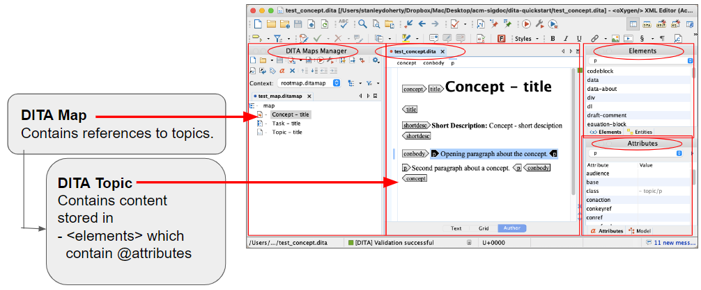

Set up a local folder
- Create a folder on your local system to store Oxygen configuration files.
For example:
C:\oxygen-config (Windows)
/Users/your-name/Desktop/oxygen-config (macOS)

Configure a default display mode for content
- In Oxygen, choose File - New to open the New dialog.
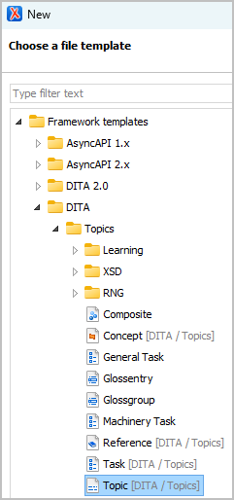
- Double-click the Topic [DITA / Topics] template under Framework templates / DITA / Topics.
Oxygen creates the topic and displays it in the right-hand Editor pane.
- In the Editor pane, click the Author button to display DITA topic content in the graphical Author Editor.
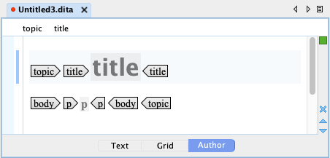

Configure a default layout for panes
- Choose Window - Load Layout - Author to arrange Oxygen panes to a preset layout named "Author".
- On the left side of the Oxygen window, delete the panes Project, Outline, and anything other than DITA Maps Manager.
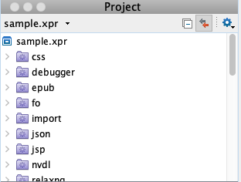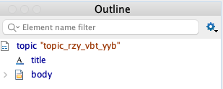
- Click the DITA Maps Manager tab on the left side of the window to make that pane active.
- On the right side of the Oxygen window, arrange the Elements and Attributes panes so they are next to one another (your preference).
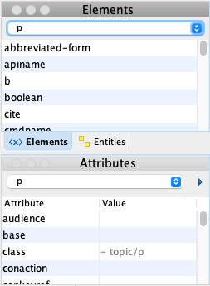
When you edit DITA content, you place your insertion pointer inside or between DITA elements. Oxygen then lists in the Elements or Attributes panes only those elements or attributes that can be inserted without invalidating the topic.
- Verify that Oxygen displays the DITA Maps Manager pane on the left, the Author editing pane in the center, and the Elements and Attributes panes on the right.
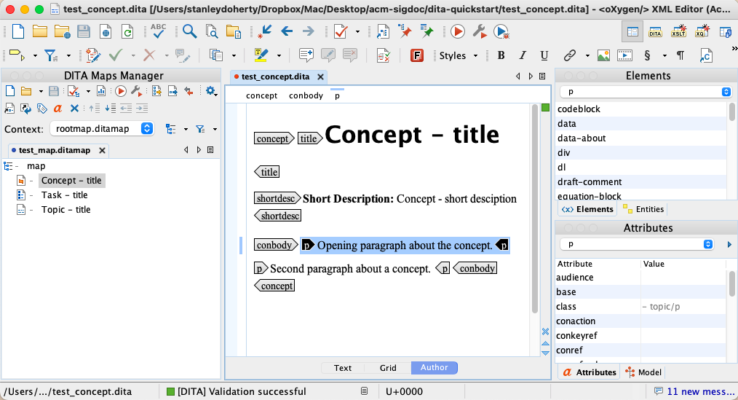
- Choose Window - Export Layout. to display the Save in file dialog.
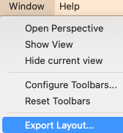
- Save the layout configuration file to the local folder you created earlier in this session.
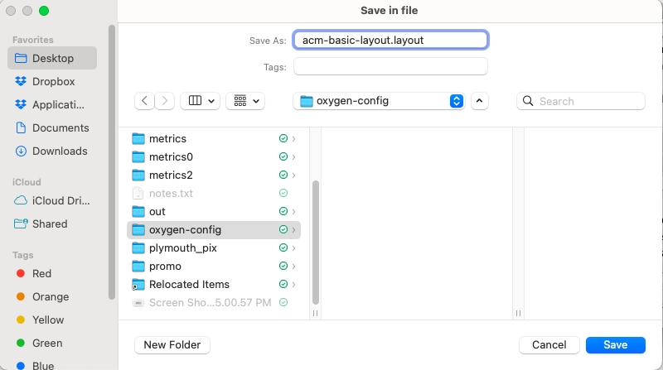
Note: You can load this layout configuration file at any time by choosing Window - Load
Layout - Custom.

Configure some global preferences
Oxygen offers dozens of configuration preferences - from the basic to the esoteric. The good news for new writers to Oxygen is that there are only a few that you need to set to become productive.

- Choose Options - Preferences - Application Layout to display the Preferences - Application Layout settings page.
- In that settings page, select the Custom button and provide the full path to the layout configuration file that you created in the previous session.
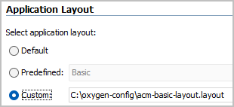
- Click OK to save the change.
Every time you open Oxygen, it will set your layout to the configuration acm-basic-layout.layout (for this example).
- In the Preferences dialog, choose Editor - Edit Modes - Author to display the settings page for the graphical editor.
- In that settings page:
a. Set the Tags display mode to "Block Tags".
b. Verify that the Display referenced content box is checked.
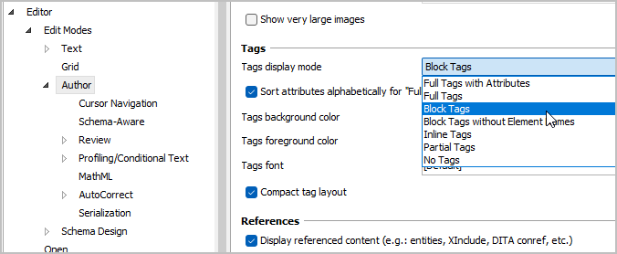
Block tags in the Author editor provide just the element names. Displaying referenced content is important once you begin working with conrefs.
- Click Apply to commit the change.
- Choose DITA to display the DITA settings sheet.
- In that settings sheet, de-select the Enable DITA 2.0 editing support box.
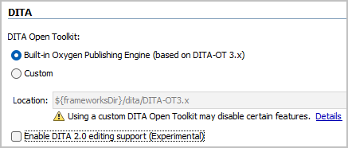
- Choose DITA - Maps and select the "Always open in the DITA Maps Manager" button.
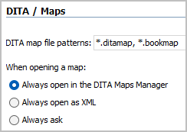
Any DITA maps that you create or open will now be displayed in the DITA Maps Manager pane and not in the Author Editor pane.
- Click Apply to commit the configuration changes.

Thank You!

See the Committee on Structured Authoring and Content Management page of the ACM SIGDOC website to learn more about committee activities, available resources, and volunteer opportunities.

See https://acm-sigdoc-structured.org to learn more about committee activities, available resources, and volunteer opportunities.

